DATABASE PROJECT REPORT
Gym Membership & Personal Training Planner
(Project ID: #9)
____________________________________________________
A. PROJECT IDENTITY
Team Name | Đông Vui
Course | INT1313 - Database Basics (CSDL)
Instructor | Lê Hà Thanh
Academic Year | 2026-2027 (Semester 1)

Team Members:

Full Name (Họ tên) | Student ID (MSSV) | Class (Lớp) | Institutional Email
Trần Đức Phương | N24DCCN154 | D24CQCN02-N | n24dccn154@student.ptithcm.edu.vn
Nguyễn Lưu Triệu Quang | N24DCCN158 | D24CQCN02-N | n24dccn158@student.ptithcm.edu.vn
Nguyễn Văn Hoàng Te | N24DCCN071 | D24CQCN01-N | n24dccn071@student.ptithcm.edu.vn

Project Title: Gym Membership and Personal Training Management Database System
B. REPORT STRUCTURE
- Introduction & Project Scope (ISO/IEC/IEEE 29148 Standard)
  - System Objective
- The Gym Membership and Personal Training Management System is designed to digitalize and streamline core gym operations. The system manages member information, class schedules, personal trainer bookings, and fitness facility maintenance records through a centralized relational database. It aims to ensure data consistency and integrity, prevent scheduling conflicts, and maintain accurate subscription and billing records to support efficient gym management and reliable data tracking.
  - Business Rules & Constraints
    - Membership & Subscription Domain (Triệu Quang)
Member - Membership - Membership Plan:
- Member: Refers to an individual or customer. A Member can remain in the system indefinitely, even if they do not currently have an active service package:
- Member ID
- Full name
- Phone number
- Necessary contact details
- Information for customer management/marketing purposes
- Profile pictures or verification photos (if required by business processes).
(Ex: Nguyen Van A)
- Membership: This refers to a member's right to access services for a specific period, established when the member subscribes to a plan. When the Membership expires or the member completes a course or service package, the Membership record must be retained in the system as history rather than being deleted.
(Ex: Nguyen Van A subscribes to the Premium plan from September 1, 2026, to October 1, 2026 / Renewing the subscription may entitle the member to special offers.)
-> A member can have multiple memberships over time.
(Ex: 01/06 → 01/07 Membership #1 with plan Basic and status is Expired, 01/08 → 01/09 Membership #2 with plan Premium and Status is Active
- Membership Plan: A type of service package offered by the gym, functioning as a Product/ Template
The plan specifies the entitlements included for the customer, such as:
- Duration
- Price
- Number of Personal Training (PT) sessions
- Access rights
- Other benefits.
-> A plan is not a specific subscription held by a member.
- Member = Who?
- Membership = Which service?
- Membership Plan = What type?
Four object: Member, Membership_Plan, Subscription, Recurring Billing/Billing_Record
- BR-M01: Each member must have a unique member identifier.
- BR-M02: Each membership plan must have a unique Plan ID and a defined price and duration.
- BR-M03: Each subscription belongs to exactly one member and is associated with exactly one membership plan.
- BR-M04: Each subscription must have a defined start date, end date, and status.
- BR-M05: A subscription has a status indicating whether it is active, expired, or cancelled.
- BR-M06: An active subscription may generate multiple billing records according to its billing cycle.
- BR-M07: Each billing record belongs to exactly one subscription.
- BR-M08: Billing records must be retained as historical records even after a subscription expires or is cancelled.
- BR-M09: Each billing record must store the amount charged and the billing period to which the charge applies.
    - Training & Scheduling Domain (Trần Đức Phương)
      - Business Rules
We have four main objects:
Trainer:
      - BR-01: A trainer can teach multiple classes.
      - BR-02: A class can have only one trainer.
      - BR-03: A trainer cannot teach two classes at the same time.
      - BR-04: If a trainer already has a scheduled class during a specific time period, they cannot accept another class whose start or end time overlaps with the existing scheduled class (e.g., if a trainer is scheduled from 9:00–10:00, they cannot accept a class from 9:30–10:30).
Class:
      - BR-01: A class must have one trainer.
      - BR-02: A class must have a specific start time and end time.
      - BR-03: The StartTime must be earlier than the EndTime.
      - BR-04: A class must have a maximum capacity.
      - BR-05: A full class cannot accept additional bookings.
      - BR-06: A cancelled class cannot accept new bookings.
Booking:
      - BR-01: A member cannot book a class that has reached its maximum capacity.
      - BR-02: A member cannot book a class that has already started.
Member:
      - BR-01: A member can book multiple classes.
      - BR-02: A member cannot book the same class more than once.
      - BR-03: A member cannot book multiple classes that take place at the same time.
      - BR-04: A member can cancel a booking.
      - Scheduling Conflict
      - A scheduling conflict occurs when a trainer or member has two training activities that overlap in time. The system must prevent these conflicts to ensure that the training schedule is valid.
Trainer Conflict:
      - A trainer cannot teach two or more classes at the same time.
      - These two classes overlap from 09:30 to 10:30.
→ Conflict: Not Allowed
      - The system should reject the second class assignment to Trainer T01.
      - The first class ends at exactly 10:30, and the second class starts at 10:30.
→ No Conflict: Allowed
Member Conflict:
      - A member cannot book multiple classes that take place at the same time.
      - These two classes overlap from 09:30 to 10:30.
→ Conflict: Not Allowed
      - The system should reject the second booking

    - Facility & Maintenance Domain (Nguyễn Văn Hoàng Te)
- Rule 1 (Asset Identification - BR-FAC-01): Fitness equipment (Equipment) is a strong entity, uniquely identified by Equipment_ID. Each equipment tracks Name, Type (Cardio, Strength, Recovery), and operational Status (Active, Under Maintenance, Broken).
Business & Technical Explanation: This rule governs gym assets. Every high-value fitness machineis modeled as a strong entity uniquely identified by its quipment_ID. To support sorting and scheduling, the system tracks: Name, Type (which must be classified as Cardio, Strength, or Recovery), and Status (which tracks whether the machine is Active, Under Maintenance, or Broken) which serves as the scheduling availability flag.
- Rule 2 (Weak Entity Constraint - BR-FAC-02): A maintenance log (Maintenance_Log) cannot exist without a parent equipment. It is modeled as a weak entity with a partial key Log_no (representing the sequential maintenance attempt for a specific machine, e.g., attempt 1, 2, 3).
Business & Technical Explanation: Maintenance logs are sequential events that have no meaningor existence without being linked to a specific machine. According to database design theory, it is modeled as a Weak Entity (represented by a double-bordered rectangle in the EER diagram). Its partial key is Log_no, representing the sequential service number for that specific machine (e.g., Treadmill #5 has Log_no 1, 2, 3...). This avoids independent ID bloat and reflects structural dependency.
- Rule 3 (Composite Primary Identifier - BR-FAC-03): The identifying key of Maintenance_Log is a composite key combining the owner's key and the partial key: {Equipment_ID, Log_no}. This allows the same machine to undergo multiple repairs over time without identification conflicts.
Business & Technical Explanation: The identifying key of the weak entity is a composite identifier: {Equipment_ID, Log_no}. This uniquely identifies each maintenance log, allowing the same machine (fixed Equipment_ID) to undergo unlimited maintenance sessions over time as Log_no increments (1, 2, 3...) without duplication, preserving a complete lifecycle log of the asset.

- Database Design (Conceptual ER/EER Modeling)

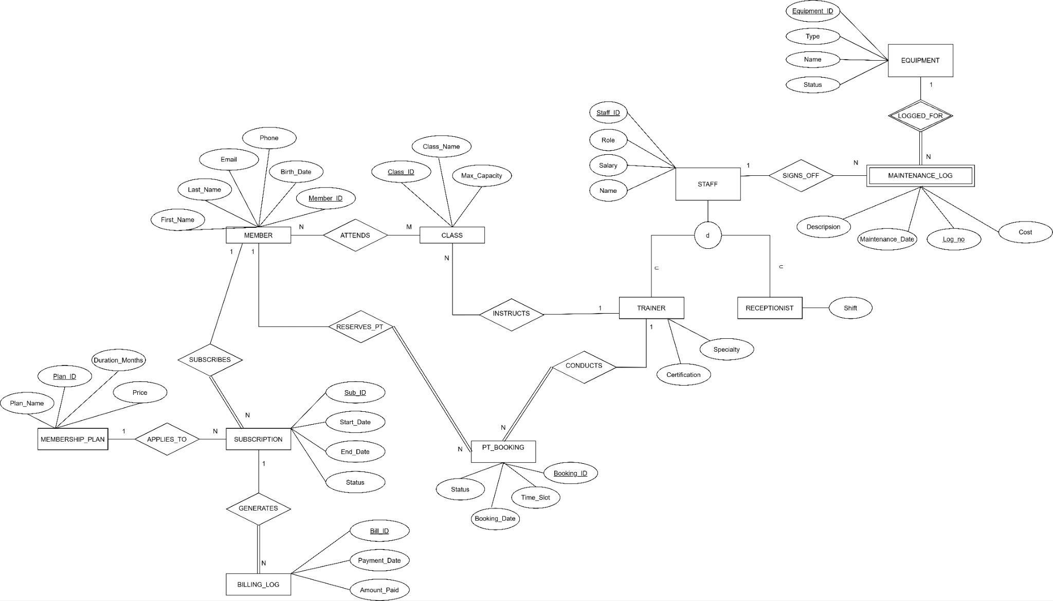

- Data Dictionary (ISO/IEC 11179 Metadata Standards)

